Documentation | Performance Analysis for prod-lg-ci-mssql-mi-1.8b554cd229a5.database.windows.net Server
Author | Mohamed Tharif
Version | V 1.0
Date of documentation | 03-07-2025

Introduction
GeoPITS is currently managing 1000+ SQL databases remotely for our global customers.
We are trusted by more than 100 clients across the globe. With 75+ database experts, our team is working on creating a minimal studio dedicated to building meaningful business processes and extensive support models with which we help companies build, manage, optimize and leverage data to empower their business. We are also a certified Microsoft Partner. Combined with an understanding of business goals and effective project management, we deliver efficient SQL server solutions.
Analysis Report
Azure SQL Database analysis was performed by DB team to identify whether SQL instances are configured as per the industry standards and follow the SQL best practices. Analysis took place at Bangalore office. The output of this analysis report would give you complete insight into current SQL Server instance configuration. The report also provides recommendations to achieve better performance as per Microsoft standard and current workload.
Technical Environment
Property | Value
SQL Server Collation | SQL_Latin1_General_CP1_CI_AS
SQL Server Edition | SQL Azure
SQL Server Machine Name | prod-lg-ci-mssql-mi-1.8b554cd229a5.database.windows.net
Database Name | DBLgLens, DBLoanguard, DBLoanguardHistory
SQL Server Clustered | NO
SQL Server Version | 12.0.2000.8
SQL Server Version Level | RTM
CPU count | 16
RAM | 87GB
Configured Mem GB | 82GB
Availability Group | NO
In-Memory Optimization | YES

1.Performance metrics and Analysis
  - CPU Utilization by SQL SERVER
The CPU utilization over the period was generally moderate, with the majority of observations (857 times) recorded at 30%. Utilization at 35% was seen 282 times, followed by fewer instances at higher levels—40% (70 times) and 45% (23 times). Peak CPU usage reached a maximum of 65%, but only on two occasions. This pattern indicates consistent and controlled CPU consumption, with occasional moderate spikes that are unlikely to cause significant performance degradation.
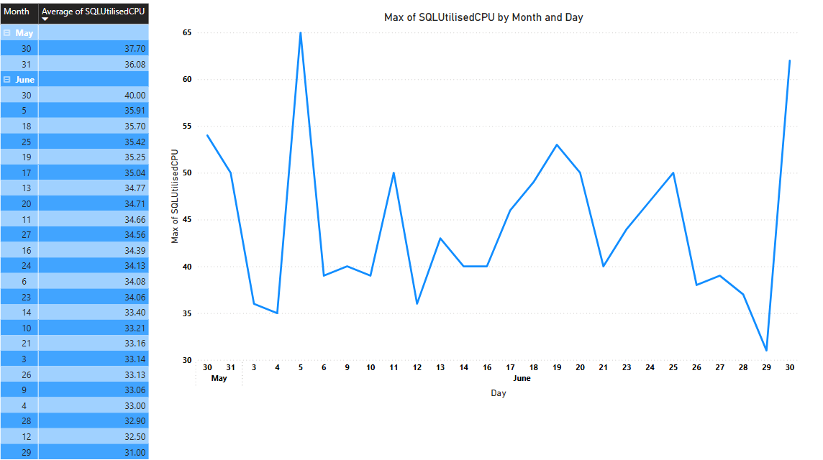
1.2. Total Number of Execution per day:
Between June 1 and July 1, query executions showed fluctuating patterns. Executions peaked on June 30 at over 2.2 million, following other high-load days like June 28 (2.04 million) and June 29 (1.57 million), suggesting sustained heavy activity during month-end processing. A noticeable dip occurred on June 22 (95k), June 15 (84k), and June 8 (90k), indicating reduced usage on weekends or non-business days. Overall, the system handled over half a million executions per day on most weekdays, pointing to consistent workload levels across the database during this period.
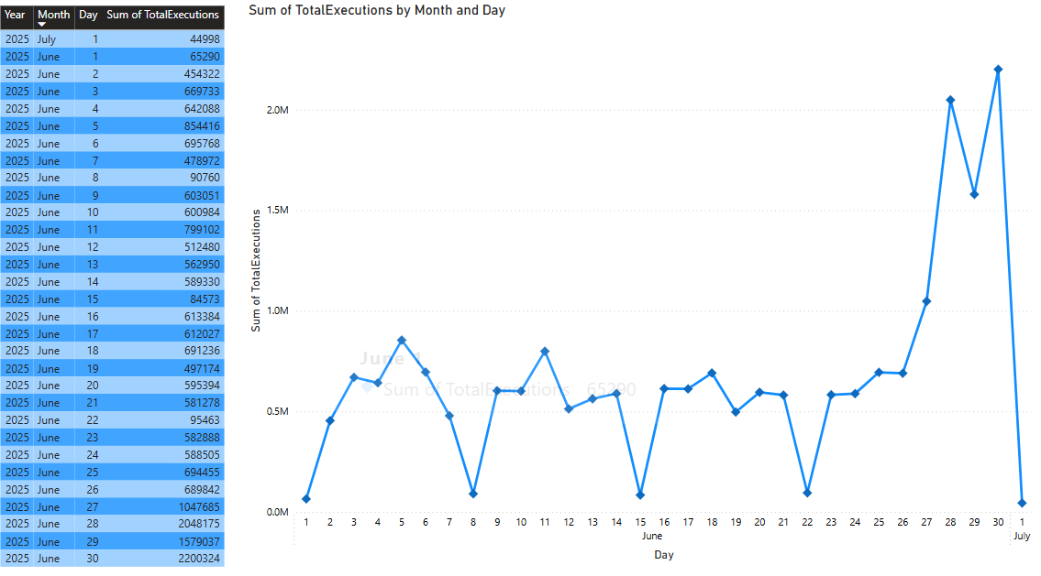
1.3. Top Queries and Wait Types
Top Consuming Queries by Physical Reads:
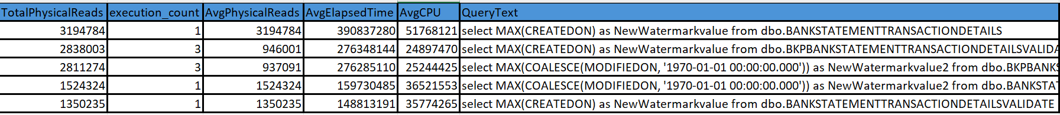
Top Consuming Queries by Duration:
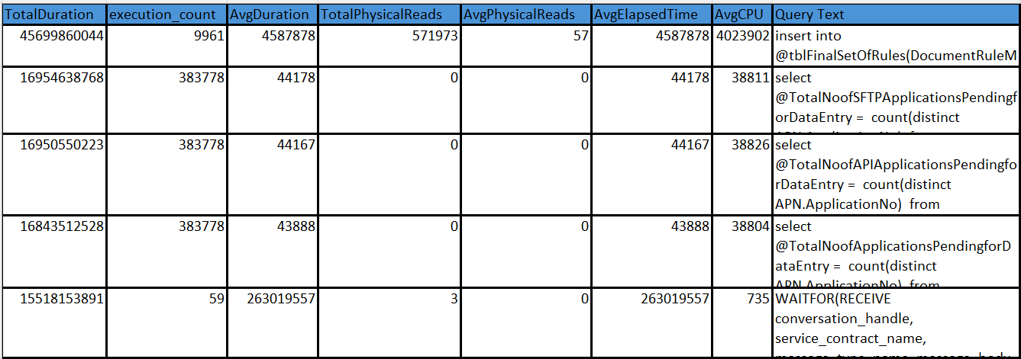
Top Consuming Queries by CPU Time:
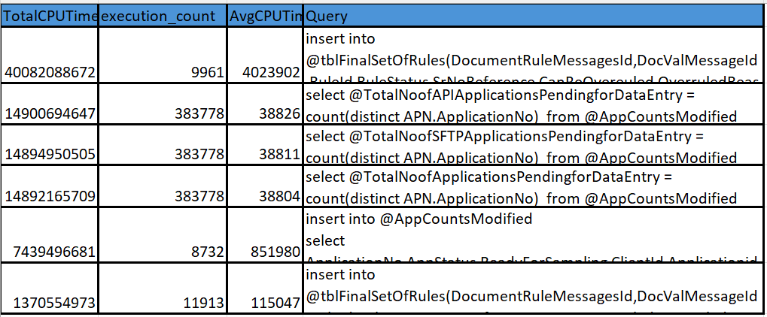
Key Observations:
- Several queries have extremely high execution counts (up to 383K) and long durations, indicating frequent and slow operations.
- Some queries show very high physical reads (over 3 million), causing significant disk I/O pressure.
- CPU consumption is heavy, with average CPU time per execution reaching over 4 million microseconds.
Top 15 Wait Types:
The wait statistics reveal that SOS_WORK_DISPATCHER is the dominant wait type, accounting for 74.51% of total wait time, which typically indicates idle CPU scheduler threads and suggests that there is no CPU performance bottleneck. Notable waits include HADR_WORK_QUEUE (9.41%) and HADR_LOGCAPTURE_WAIT (2.19%), both associated with Always On availability group operations, hinting at overhead in log capture and secondary synchronization. Other background waits like XE_LIVE_TARGET_TVF, BROKER_TRANSMITTER, and QDS_PERSIST_TASK_MAIN_LOOP_SLEEP each contribute around 1.76% to 0.88%, reflecting background diagnostics, broker messaging, and query store persistence activity. These are generally benign unless they grow over time. Overall, the system shows healthy CPU availability.
Wait_type | Wait_time_sec | Waiting_tasks_count | total_waits(Percentage)
SOS_WORK_DISPATCHER | 14537597.93 | 6406518 | 74.51333017
HADR_WORK_QUEUE | 1835561.32 | 7111010 | 9.408279644
HADR_LOGCAPTURE_WAIT | 426839.635 | 1624610 | 2.187792151
XE_LIVE_TARGET_TVF | 344678.57 | 24361 | 1.766670685
BROKER_TRANSMITTER | 344602.611 | 2671456 | 1.766281352
HADR_TIMER_TASK | 172538.373 | 380469 | 0.88435578
HADR_FILESTREAM_IOMGR_IOCOMPLETION | 172367.173 | 343244 | 0.883478284
QDS_PERSIST_TASK_MAIN_LOOP_SLEEP | 172338.489 | 2873 | 0.883331262
SP_SERVER_DIAGNOSTICS_SLEEP | 172203.907 | 21962 | 0.882641454
PVS_PREALLOCATE | 172195.489 | 593389 | 0.882598307
DIRTY_PAGE_POLL | 171928.39 | 1570917 | 0.881229275
QDS_ASYNC_QUEUE | 171382.01 | 8705 | 0.878428772
HADR_FABRIC_CALLBACK | 171003.627 | 589 | 0.876489347
PWAIT_EXTENSIBILITY_CLEANUP_TASK | 171000.718 | 96 | 0.876474437
BROKER_EVENTHANDLER | 169720.527 | 86 | 0.869912741
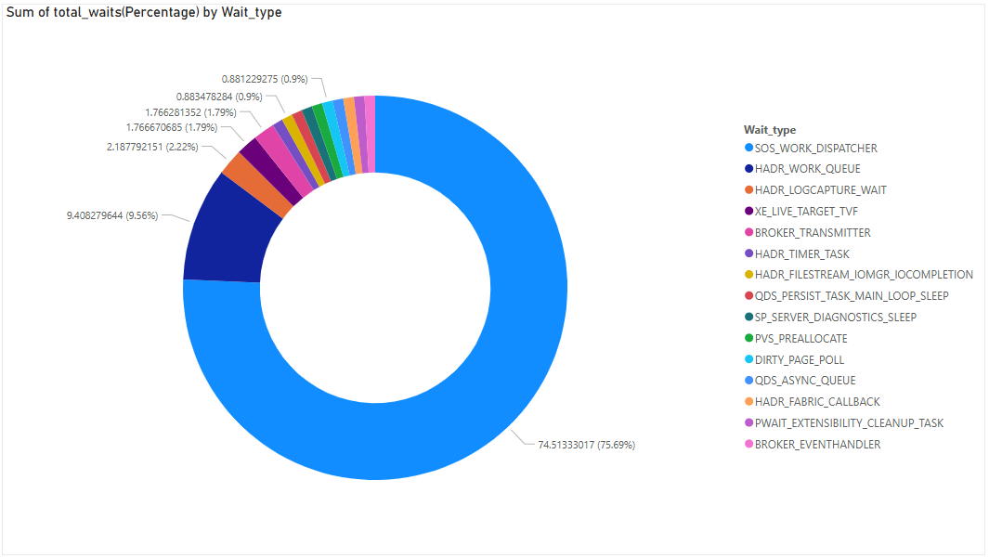

3.Index Fragmentation:
The index fragmentation analysis across multiple databases reveals varied levels of index fragmentation. In the DBLoanGaurd database, a substantial number of indexes exhibit fragmentation, with 9 indexes having fragmentation greater than 90%, 3 between 80-90%, and 1 between 60-70%. Additionally, there are 2 indexes in the 50-60% range, 5 in the 40-50% range, 7 between 30-40%, 10 between 20-30%, 14 between 10-20%, and a significant 211 indexes with minimal fragmentation (0-10%).
In the DBLoanGaurd_History database, 11 indexes fall within the 0-10% fragmentation range, indicating low fragmentation levels.
The DBLgLens database shows 3 indexes with 0-10% fragmentation, 1 index between 30-40%, and 1 index with fragmentation above 90%, which may require immediate attention.
It is important to note that several highly fragmented indexes—particularly those above 30% fragmentation—may also have high page counts, potentially impacting query performance by increasing I/O operations. Targeted index maintenance, such as rebuilds for high fragmentation and reorganizations for moderate fragmentation, is recommended to enhance database performance and reduce resource overhead.
Database_Name | Fragmentation_range | Index_count
DBLoanGaurd | 0-10% | 211
DBLoanGaurd | 10-20% | 14
DBLoanGaurd | 20-30% | 10
DBLoanGaurd | 30-40% | 7
DBLoanGaurd | 40-50% | 5
DBLoanGaurd | 50-60% | 2
DBLoanGaurd | 60-70% | 1
DBLoanGaurd | 80-90% | 3
DBLoanGaurd | Greater than 90 | 9
DBLoanGaurd_History | 0-10% | 11
DBLgLens | 0-10% | 3
DBLgLens | 30-40% | 1
DBLgLens | Greater than 90 | 1

4.Missing Index:
The audit noted that several databases could benefit from additional indexing to enhance query performance. While not currently critical, the lack of key non-clustered or covering indexes may result in slower query execution, especially on tables with a high number of rows and elevated scan-to-seek ratios. This performance impact may be due to missing indexes, insufficient covering strategies, or outdated statistics. Implementing the recommended indexes and maintaining up-to-date statistics can significantly improve efficiency and ensure optimal database responsiveness.

Database  name | Table_name | create_index_statement | User seeks | Last user seek | Avg user  impact
DBLgLens | applicationDocuments | CREATE INDEX [IX_applicationDocuments_ApplicationNo, LoanguardId_] ON [dbo].[applicationDocuments] ([ApplicationNo], [LoanguardId]) | 1697 | 6/27/25 12:48 PM | 70.42
DBLgLens | applicationDocuments | CREATE INDEX [IX_applicationDocuments_ApplicationNo, LoanguardId_] ON [dbo].[applicationDocuments] ([ApplicationNo], [LoanguardId]) INCLUDE ([DocumentTypeId], [LGDocumentName], [DocumentName], [LGDocId], [DocumentDescription], [DocumentStatus], [Status]) | 1154 | 6/27/25 12:48 PM | 70.38
DBLoanguard | Applications | CREATE INDEX IX_Applications_ScoreReportStatusAppStatus ON ([ScoreReportStatus], [AppStatus]) INCLUDE ([ApplicationNo], [ProductId], [ClientId], [ModifiedOn], [ReverseAPIStatus], [CallBackPostServiceStatus], [CallBackPostAttemptedOn]) | 2820 | 6/30/25 12:38 AM | 100
DBLoanguard | Applications | CREATE INDEX IX_Applications_AppStatusCreateMode_ClientId ON ([AppStatus], [CreateMode], [ClientId]) INCLUDE ([ProductId], [CreateStatus], [ScoreStatus]) | 2585 | 6/30/25 12:40 AM | 80.45
DBLoanguard | AadharCard | CREATE INDEX  IX_AadharCard ON ([ApplicationNo], [LoanguardId], [DocumentIndex]) | 9256 | 6/30/25 12:11 AM | 99.95
DBLoanguard | ITRValidate | CREATE INDEX  IX_ITRValidate ON ([LoanguardId], [DocumentIndex]) | 1259 | 6/29/25 6:33 PM | 99.94
DBLoanguard | TextractProcessInfo | CREATE INDEX  IX_TextractProcessInfo ON ([DocValMessageId]) | 8701 | 6/30/25 12:11 AM | 99.94
DBLoanguard | DocumentOriginalityCheck | CREATE INDEX IX_DocumentOriginalityCheck ON ([DocValMessageId]) | 5570 | 6/29/25 8:43 PM | 99.9
DBLoanguard | SalaryTransactionDetails | CREATE INDEX IX_SalaryTransactionDetails ON ([SalaryTransactionID], [HeadType]) INCLUDE ([HeadValue], [HeadName], [YTDHeadValue]) | 3396 | 6/29/25 8:40 PM | 99.9
DBLoanguard | PanCard | CREATE INDEX IX_PanCard ON ([ApplicationNo], [LoanguardId], [DocumentIndex]) | 5741 | 6/30/25 12:11 AM | 99.77
DBLoanguard | MSEBBillValidate | CREATE INDEX  IX_MSEBBillValidate ON ([ApplicationNo], [LoanguardId]) INCLUDE ([MSEBName], [MSEBAddress], [MSEBDate], [MSEBConsumerNo], [MSEBBillingUnit], [DocumentIndex], [MSEBBillingAmount]) | 2316 | 6/29/25 10:44 PM | 99.72
DBLoanguard | VoterIdCardValidate | CREATE INDEX IX_VoterIdCardValidate ON ([ApplicationNo], [LoanguardId]) INCLUDE ([VoterIdCardNo], [VoterIdCardHolderName], [VoterIdCardHolderAddress], [VoterIdCardDateOfIssue], [VoterIdCardNoBackSide], [DocumentIndex], [VoterCardBirthDate]) | 2316 | 6/29/25 10:44 PM | 99.61
DBLoanguard | VehicleRCValidate | CREATE INDEX  IX_VehicleRCValidate ON ([ApplicationNo], [LoanguardId]) INCLUDE ([VehicleRCNumber], [VehicleOwner], [DocumentIndex], [VehicleChassisNumber], [Hypothecation], [RegistrationDate], [EngineNo], [Address], [VehicleModel], [MftgYear]) | 2316 | 6/29/25 10:44 PM | 99.47
Table2: Missing Index Impact

5.Unused Index
Unused indexes in SQL Server refer to indexes that are not being utilized by queries. These indexes consume storage space and can impact the performance of data modification operations (such as INSERT, UPDATE, and DELETE) as well as the overall database performance.
Database Name: DBLoanGaurd
Table_Name | Index_Name | UserSeeks | UserScans | User  Updates
dbo.DocumentValidatingMessages | DVDocIdDocAppSts | 0 | 0 | 85991
dbo.DocumentValidatingMessages | DValDoAppSts | 0 | 0 | 85759
dbo.DocumentValidatingMessages | DocAppStsApcntIdAppId | 0 | 0 | 85759
dbo.TimeAnalysis | TADIdUId | 0 | 0 | 73549
dbo.TimeAnalysis | TAUID | 0 | 0 | 73549
dbo.TimeAnalysis | TimeAnaDocIdUserId | 0 | 0 | 73549
dbo.Applications | ApnCreatStaAppNoProdIdAppDtAppSt | 0 | 0 | 9993
dbo.Applications | AppnProdCliAppNoAppDtAppSts | 0 | 0 | 6921
dbo.Applications | APPLication_CreateMode | 0 | 0 | 2820
dbo.SalaryTransactionDetailsValidate | SalTraDetValHeadType | 0 | 0 | 474
dbo.BankNarrationCategories | IndBNarrCNarrLables | 0 | 0 | 229
dbo.bkp_BankNarrationCategories | IndBNCNarrLables | 0 | 0 | 0
Table3: Unused Index Impact

6.Disk I/O Performanace:
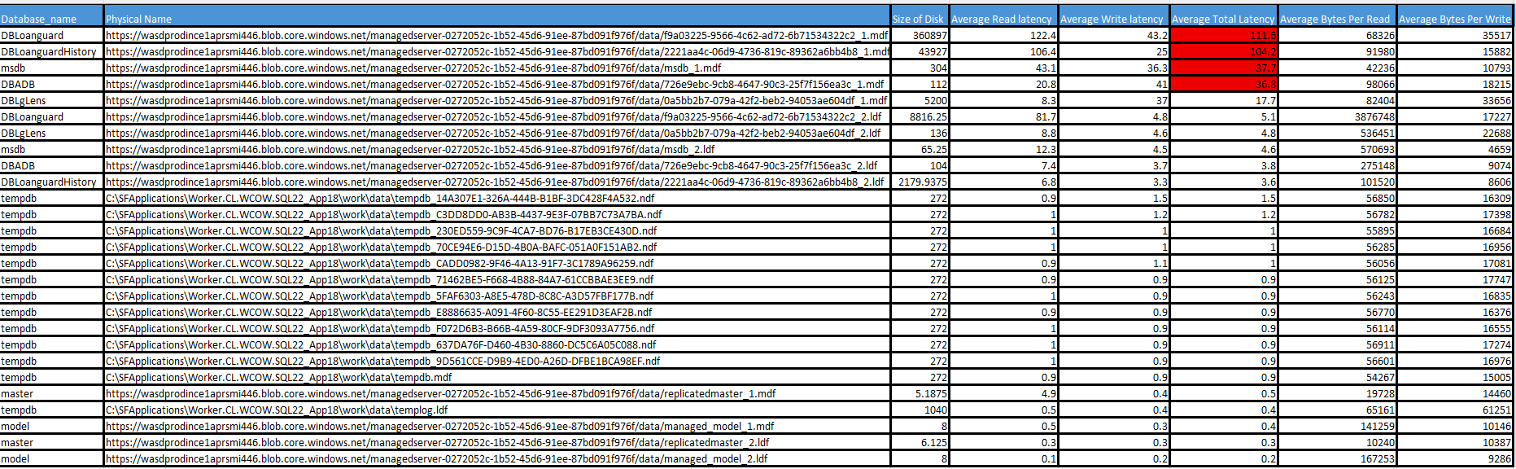
The disk latency analysis of the SQL Server instance reveals significant I/O performance issues, especially in databases such as DBLoanguard, DBLoanguardHistory, and msdb. These databases show very high average total latencies—above 100ms—with DBLoanguard experiencing 122ms for reads and 111ms overall. This suggests substantial delays in data retrieval operations. In contrast, tempdb performs optimally with consistently low latencies (under 2ms), confirming that temporary objects and sort operations are not contributing to the I/O bottleneck. Additionally, high average bytes per read in certain databases indicate possible full table scans, likely caused by missing or suboptimal indexes.

7. Cumulative Recommendations

7.1 Query Performance & Wait Types
- Optimize queries by ensuring they are selective and avoid using SELECT *; retrieve only the necessary columns.
- Evaluate and enhance indexing to reduce high physical reads contributing to PAGEIOLATCH_SH waits.
- Increase SQL Server memory allocation to improve data caching and reduce disk I/O.
- Adjust the server’s parallelism settings by setting MaxDOP to 4 and increasing the Cost Threshold for Parallelism to 50, to control excessive parallel query execution.

7.2 Index Optimization

Index Fragmentation
- Rebuild indexes with fragmentation greater than 30%, especially those associated with large page counts to improve performance.
- Reorganize indexes with moderate fragmentation (10%–30%) as part of routine maintenance.

Missing Indexes
Implementing recommended missing indexes will significantly reduce disk I/O, addressing one of the key performance bottlenecks observed during analysis.

Unused Indexes
Identify and remove persistently unused indexes, especially on write-intensive tables, to lower maintenance overhead and enhance DML performance.

7.3 Disk I/O Performance
- Optimize indexing and refine queries that trigger full table scans.
- Implement missing indexes and apply selective filters to minimize read/write latency.
- Monitor latency metrics and consider storage improvements if high stall times persist, especially for files with consistently high read/write delays.

